Title of the presentation

Author1 First Name Author1 Last Name (Author1 affiliation), Author2 First Name Author2 Last Name (Author2 affiliation)…
Presentation type
Collaboration proposal | On-going collaborative work | Result of research work

Keywords
Keyword 1, Keyword 2, …. Keyword n.

Introduction
Normal text in a normal paragraph. Normal text in a normal paragraph. Normal text in a normal paragraph. Normal text in a normal paragraph. Normal text in a normal paragraph. Normal text in a normal paragraph. In the aerospace domain, some works are addressing hybrid Artificial Intelligence (AI) for fault diagnosis (1) and explainable AI for maintenance (2).

A section
Normal text in a normal paragraph. Normal text in a normal paragraph. Normal text in a normal paragraph. Normal text in a normal paragraph. Normal text in a normal paragraph. As shown in Figure 1, it is a brain, a printed circuit board and an aircraft.

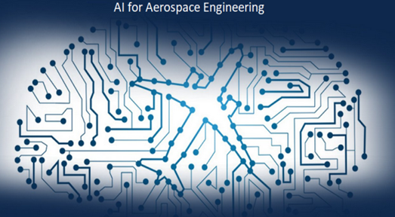
Figure 1: Caption of the figure

Another paragraph. Normal text in a normal paragraph. Normal text in a normal paragraph. Normal text in a normal paragraph. Normal text in a normal paragraph.

Another section
Another paragraph. Normal text in a normal paragraph. Normal text in a normal paragraph. Normal text in a normal paragraph. Normal text in a normal paragraph. Figure 1 presents concepts related to brain, printed circuit board and aircraft.

Figure 2: Caption of another figure

Another paragraph. Another paragraph. Another paragraph. Another paragraph. Another paragraph. Another paragraph.

Another paragraph. Another paragraph. Another paragraph. Another paragraph. Another paragraph. Another paragraph.

Conclusion

Another paragraph. Another paragraph. Another paragraph. Another paragraph. Another paragraph. Another paragraph.

References:

- Ezzat D, Hassanien AE, Darwish A, Yahia M, Ahmed A, Abdelghafar S. Multi-objective hybrid artificial intelligence approach for fault diagnosis of aerospace systems. IEEE Access. 2021 Mar 9;9:41717-30.

- Shukla B, Fan IS, Jennions I. Opportunities for explainable artificial intelligence in aerospace predictive maintenance. InPHM Society European Conference 2020 Jul 19 (Vol. 5, No. 1, pp. 11-11).

Note : References are in Vancouver style

